
415 Fourth Range Road • Pembroke NH 03275 USA
603-485-2248 • WWW.NHRC.NET
NHRC-VOX Advance Information

Introduction

Purpose
Many modern radios have no CAS signaling readily available. Traditional Voice-activated switching can’t be used because the radio circuit setup time is not fast enough, and the first syllable is garbled or completely missing.
The NHRC-VOX combines a de-bounced, re-timed VOX with an audio delay long enough to allow the radio circuit to come up without the loss of the first few syllables.

Installation

J1 Connections
J1 is a 6-pin .100 center connector. (Mate supplied)
Pin | Usage | Notes
1 | +12 | +12 nominal, no less than 10 volts, no more than 15 volts
2 | Audio In | 1V P-P from your audio source (3Vp-p absolute max)
3 | Audio Out | 1V P-P toward transmitter
4 | Active High output | DO NOT SHORT TO GROUND. 50 mA max
5 | Active Low output | DO NOT SHORT TO +V. 50 mA max.
6 | Ground | Power supply negative

CAUTION: Mis wiring / reverse polarity may damage the NHRC-VOX . Damage due to accidental mis wiring is not covered by the NHRC limited warrantee.

Indicators
The NHRC-Squelch has three diagnostic indicator LEDs:
ID | Color | Label | Purpose
D2 | Red | PWR | Power On
D3 | Green | CAL | Squelch Noise Threshold Calibration
D5 | Green | VOX | VOX operation

Adjustments

VR1 “AUD LVL” Audio Input Level calibration
Potentiometer VR1 adjusts the audio level INTO the NHRC-VOX.
After you have made all of your electrical connections and the VOX board is powered on. Transmit a 1Khz tone 3KC deviation to the receiver connected to the NHRC-VOX.
With an oscilloscope, Probe TP-1 (signal) and TP-2 ( gnd) and adjust VR-1 for 2.5V p-p . If no scope available use a TRUE RMS DVM and set TP-2 to ~ 1.75V RMS. Be careful not to over drive the audio input of the NHRC-VOX as distorted output may occur. The speaker output of many radios are capable of delivering several volts of audio. The NHRC-Vox is rated for a MAXIMUM input voltage of 3Vp-p.

With this adjustment performed, you will now set the Vox threshold.

VR2 “CAL ADJ” Squelch Noise Threshold Calibration
Potentiometer VR2 adjusts the sensitivity of the noise detector that forms the heart of the VOX timing. After the VR1 volume level is adjusted, adjust VR2 while providing a minimally weak audio signal is present. Adjust VR2 for some visible flickering of the D3 CAL Led indicator.
Use a transceiver and transmit a variety of voice signals to your receiver. The cal light illuminates while the VOX is detecting that voice audio is present. Adjust as necessary to obtain proper VOX detection.
JP1 Jumpers – Audio Delay Time
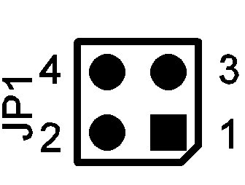
Jumpers JP1 set the audio input to output delay time. With both jumpers removed, the audio delay is in the area of 250 ms. With both jumpers installed, the audio delay is in the area of 100 ms. With one jumper installed, the value is closer to 150 ms. Select the shortest amount of time that leaves first transmitted syllables intact. Jumpers are installed from JP1 1-2 and 3-4.

JP2 Jumpers – VOX re-timing delay and output polarity.
Jumpers on header JP2 select the amount of VOX delay time, and one can invert the polarity of the output signaling. JP2 is a 5x2 .100” header block. It has 5 pairs of pins that can have jumpers installed
The first pair of headers are right next to TP3 is JP2-1, the next pair JP2-2 and the last pair is JP2-5
JP2-1 to JP2-3 are used to adjust the delay time.
JP2-5 | JP2-3 | JP2-1 | Delay Time
Missing | Missing | Missing | 250
Missing | Missing | Installed | 500
Missing | Installed | Missing | 750
Missing | Installed | Installed | 1000
Installed | Missing | Missing | 1250
Installed | Missing | Installed | 1500
Installed | Installed | Missing | 1750
Installed | Installed | Installed | 2000

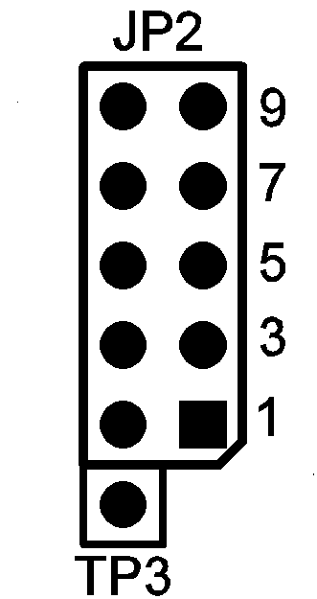
JP2-7 is used to invert the output signaling of the NHRC-VOX. Removing the jumper inverts the output. (Jumper normally installed)

Service / Support

Warranty
See standard warrantee terms at www.nhrc.net

Contact NHRC
We want your project to be successful. Please contact us if you have questions or comments about the operations of our products

You can telephone us at 603-485-2248 or email us at hardware-support@nhrc.net or software-support@nhrc.net

